Coonabarabran Rotary Bulletin
Mon 16 July 2018

Next Meetings

Mon 30 July - fifth Monday in the month - Social evening - Pot Luck at the Wilkins. Please let Hugh know if you can come. Phone or text to 0427 421 396.

Mon 6 Aug - District Governor’s visit

Calendar
Mon 23 July - Regional Bank disbursement of funds
Sat 28 July - Race Meeting
Fri 3 August - Primary school Athletics carnival
Mon 6 August - District Governor's visit
Sat 11 August - Picnic table ‘launching’ proposed
Fri 17 August - Primary Zone Athletics carnival
Mon 20 August - Dinner meeting
Fri 24 August - Trek4Kids lunch
Sat 25 & Sun 26 August - MHERV van in residence
Tues 25 Sept - Childrens Day - BBQ
13-14 October - Suggested weekend for club trip.

Click here for the July edition of Rotary on the Move
Click here to read the Gunnedah West Rotary bulletin Kowandi

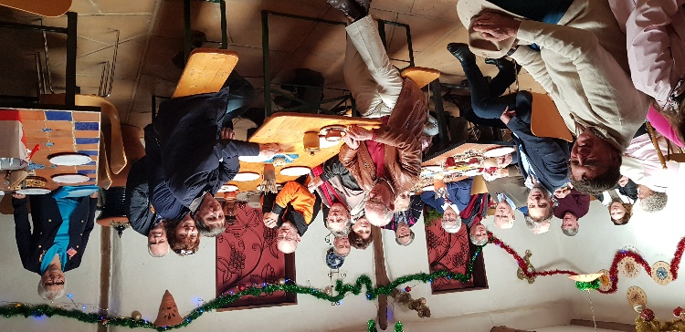
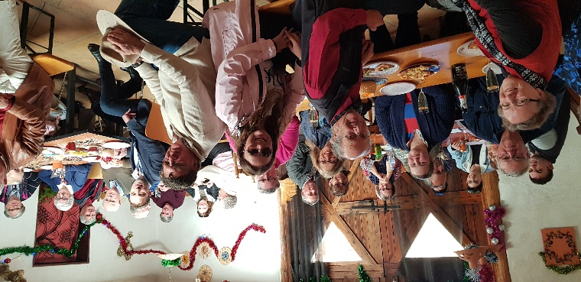

Pilliga Pottery Picnic

Many thanks to AG Aileen and President of Narrabri Darrell Tiemens for organising the afternoon at Pilliga Pottery on Sunday. It was such a pleasant day and we raised over $400 for the Partner’s Project - research into motor neurone disease. It was a great way to meet up with some of our friends from other clubs in Clusters 7 & 9 …… and the pizzas were delicious!

Notes from the last meeting 15 July
- Correspondence received - Thanks from Prostate cancer assoc, and the Radio station. Also Honeywell Engineering information, and a query from Penrith Valley Rotary asking how we are affected by the drought.
- It was agreed that we support all the local schools with $50 for their Awards Nights. Moved Aileen, seconded Robert.
- We will be catering for the Races on Sat 28 July. The Jockey Club is not expecting a large crowd.
- Since we have a fifth Monday this month on Mon 30 July, but do not need to hold a club assembly at this time, we will have a social get-together - a Pot Luck at Wilkins. Everyone, members, partners and friends are very welcome - 6.00pm for 6.30pm.
- The next Dinner meeting on Mon 6 August will be for the District Governor’s visit. Tickets are available from Bob for the Partner’s Project raffle. Prize will be a portrait painted by an outstanding artist.
- If the sign for the picnic table is finished, we will have a Coffee and Cake gathering to Launch it hopefully on Sat 11 August.
- Trek4Kids, a group who arrange an outback trek raising funds for the Starlight Foundation, would like us to provide lunch for them (60 people) on Friday 24 August.
- The MHERV (Mens Health Education Rural Van will be in Coonabarabran on the weekend of 25-26th August. We will need to publicise the visit, and provide some receptionists, as well as accommodation and meals for the travelling nurse. Bob to write to the Chamber of Commerce requesting a place outside Rolls’ shop, and exemption from payment.
- We discussed the idea of a weekend trip later in the year. Several destinations were mentioned with Uralla suggested as a likely choice. Hugh and AG Aileen will follow up on this idea. Possible date - 13-14 October.
- We have been asked to help move some shelves in the DPS office.
- Marie has proposed we hold a function to provide some assistance for farmers and others struggling with the drought. A small group discussed this in more detail after the meeting - suggested date Friday 10 August. More to come.

District Newsletter
Have you been receiving the District Newsletter, this year called The Inspirator? It is being sent directly to every member this year instead of via the club secretary. Let me know if you are not receiving it. Here are some of the items in the first two editions:

1. The Australian New Zealand conference in Hobart 14–16 September.
2. How to donate to the District RAWCS Drought Relief NSW project.
3. The Rotaract Roadshow - encouraging the creation of new Rotaract clubs, one in each Cluster.
4. The Hamburg International Convention 1-5 June 2019, and the Friendship Exchange in the two weeks beforehand. Applications will close 31 July.

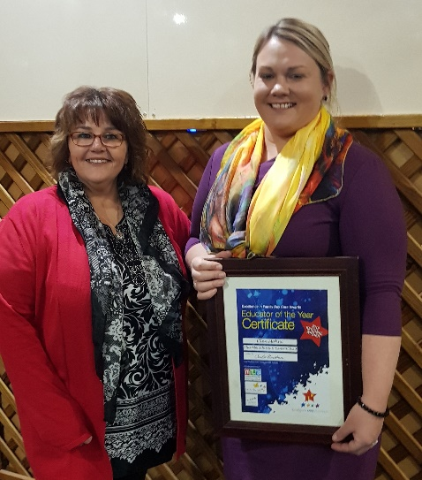
Guest Speaker Ellen Mahne
Ellen Mahne gave an account of her journey in early education teaching and her business in Family Day Care. She gave an animated and detailed account of nominating for her award as Educator of the Year for the Central and Western regions, revealing a commitment to detail and thorough planning for best educational outcomes. It was good to have Michelle Capewell, Ellen’s supervisor, attend the meeting to hear her speak. We were pleased to hear a comment from Ellen at the end that she looks forward to becoming a Rotarian one day. Out with the Membership forms!!

The Weekly Bulletin of the Rotary Club of Coonabarabran Inc. Club No 17922
President: Jo Wilkin Secretary: Bob Guichelaar Treasurer: John Sawyer. Charter 13 May 1949

