|
BULLETIN – 03/2019/20
14 May 2019
Rotary Club of Coonabarabran
Club No 17922 Chartered 13 May 1949
RI President: Barry Rassin Governor D9650: Lorraine Coffey AG: Aileen Bell
Club President: Ian Bell
President Elect/VIce President: Mal Unicomb Immediate Past President: Jo Wilkin
Secretary: Lindsay Wilkin Treasurer: John Sawyer
Public Officer: Bob Guichelaar Public Officer: Bob Guichelaar
Directors
Club Service: Hugh Raadgever Membership: Mal Unicomb
Public Relations: Aileen Bell Youth Service: Jo Wilkin
Rotary Foundation: Bob Guichelaar International Service: Rob Noakes
Vocational Service: Simon Tighe Community Service: Rob Cox
Rotary will meet each Monday 6 for 6.30 – Coonabarabran Bowling Club. Apologies and additional guests:
Phone or Text by 9am Monday to Hugh Raadgever 0427 421 396; in Hugh’s absence John Sawyer will take
dinner bookings on 0448 130 630. Partners are welcome to attend our meetings at any time.
From time to time there will be changes to programs to accommodate requirements but these will be
advised in advance of the changes. The following program will be adhered to as much as possible:
Week 1. A Business Meeting with a speaker – good night for prospective members
Week 2 a Club Meeting – business only
Week 3: Vocational Meeting - speaker or visit - good night for prospective members
Week 4: A Breakfast Meeting – moving around town - good for prospective members
When we have 5 Mondays in a month we will have a family and guests’ night – sometimes trivia, sometimes games, sometimes a Rotarian talking about a Rotary Project – bring your families and prospective members along.
Following the Week 2 Meeting there will be a Board Meeting and on the 3rd Month there will be a Club Assembly
for the 2nd meeting preceding the board meeting. Club assemblies will occur from the first week of July. A Duty Roster will be published each month with member duties for each week – if a member cannot do the task allocated - then they should take responsibility for finding a replacement - getting someone to do their task.
IT IS NOT ESSENTIAL TO EAT AT ROTARY MEETINGS EACH WEEK, IF YOU CHOOSE TO DINE ELSEWHERE PLEASE NOTE THERE IS AN $8 MEETING FEE TO BE PAID AND YOU MUST ADVISE CLUB SERVICE THAT YOU DO NOT REQUIRE A MEAL.

President Ian says ….
Yet another week has passed
- Business Meeting with 12 Rotarians in attendance; this made for a quick meeting and the Board Meeting
was able to commence before 8pm.
- We still send wishes for a speedy recovery to Jenni Tighe who has not only broken her leg but also sprained her wrist – crutches can do that you know!!!
- Thank you to those in attendance who agreed to attend Coonamble RC Changeover and 60th Birthday on 22 June – if you would like to go over on 22 June .. contact John Sawyer.
- From time to time we wonder how our distributed funds are used by recipients – well this year, letters of thanks were received from Guides and Days for Girls who both outlined their use of Rotary Funds.
- Roland was able to report on another successful RYDA event and thanked Robyn for being his voice on the day. Coonamble High teachers reported it as a “fine” program and that they would send more students in future years.

- Rotary is supporting the establishment of a Suicide Prevention Committee for Coonabarabran and will cater for the 14th May establishment meeting. The need for this initiative was raised in the light of yet another needless local death and members extended their condolences to Peter Hardy and the family of Tristan Hardy.
- With this bulletin I am sending images taken since Changeover – makes us realise how busy we have been

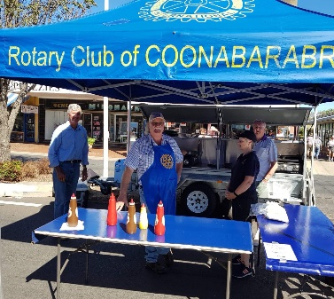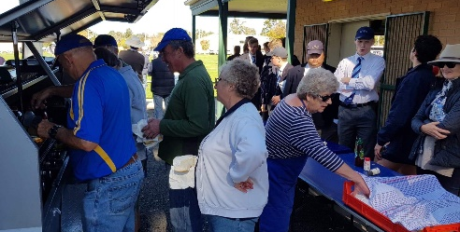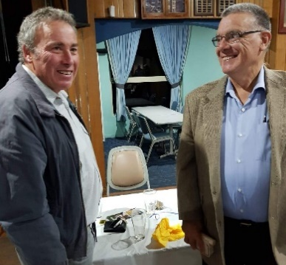
The Bunny Bazaar and the Junior Rugby Carnival featured Rotarians & Rtn Michael Deep introduced Russell
their partners – is the new catering trailer “broken in” yet? James to members - ?? a new face
a new member ??
Attending the Catering Services Meeting were members and visitors. Rtn Ian McLean, John Mercer, Pam Southwell, 2 from Binnaway Lions Club, Mitch Rawlinson and Rtns Mal Unicomb and Rob Cox
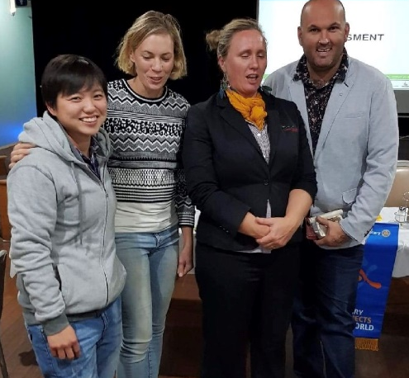
Kim and Regina from P Pottery with Simone Tenne Schmidt – EHO with WSC and Cllor Kodi Brady shared understandings of requirements for catering services

- In my enthusiasm I have to admit I missed the Member Profiles last meeting – so next meeting its Kevin and Aileen with Rob Cox and Brooky on 27 May
- Thank you to those who attended the very quick Board meeting on Monday evening
- To John Sawyer, our best wishes for a speedy return to full recovery and also thank you for the display shelf/ves built for the Bookshop.
- The discussion around the Re Districting of Rotary continues and all members will receive a paper distributed by District Management.
Cheers
Ian

LOOKING FORWARD
Change Overs .. Coonamble (and their 60th birthday) 22 June; Cherry Brook – 23rd June (Ian and Aileen); Gunnedah Mon 24 June (Aileen); Gunnedah West Thurs 28 June (Aileen), Boggabri and Narrabri – July (Aileen and Ian)

Rob and Rowanne have been preparing the Expo Roster .. please offer to assist
where possible. We will be shorthanded this year too .. Hugh & Sue, Lindsay
& Jo are overseas for RI Conference. John Sawyer, while he is thinking he will be
fine, is having knee surgery this week and will most certainly not be at full capacity
– this means Trish will be working reduced shifts too.
Six valuable “turner uppers”down is a big loss and thank goodness that
former member Peter Young has offered to work some shifts with us.
Story is that there are more than 430 horses booked for the
Expo – more than last year!!!
Please be ready to record your ability to work on this
catering task that is a major fundraiser for the Club.

A reminder to those who are getting close to needing to renew their WWC credentials – do it now!

Roster May/June/July
Please note there are changes to this roster .. Please put this roster and calendar aside for your convenience for quick reference
please remember it is YOUR RESPONSIBILITY to ensure this roster is adhered to
.. please arrange an alternative if you cannot do the duty listed
DATE OF MEETING | DINNER SERVICE | WELCOME TO ROTARY | MEMBER PROFILE | INTRO GUEST SPEAKER | THANK GUEST SPEAKER
6 May  Speaker – Simone Schmidt | Aileen & Kevin | Jim | missed | Michael | Col W
13 May  Business  Board | Rob C & Laurie D | Paul | missed | Not required | Not required
This week  20 May  Vocational Meeting  Kim O’Donnell | Rob Dean & Bob G | Robyn P | Kevin & Aileen | Mal | Jim P
27 May  Breakfast at Feathers | Bob G & Kevin | John S | Peter Brookhouse & Rob C | Not required | Not required
3 JUNE  All members at Expo please .. | Expo | Pres Ian | Not required | Not required | Not required
10 JUNE | Queens Birthday Weekend – no Rotary | Not required | Not required | Not required | Not required
17 JUNE  Business  Board Meeting | Dave Maher & Procter | Simon Tighe | Laurie D | Not required | Not required
24 JUNE  Vocational | Paul M &  Rob Noakes | Mal Unicomb | Rob Dean | Peter Brookhouse | Rob Noakes
1 JULY  Speaker Mting | Procter & Robyn | Col W | Michael Deep | Jo Wilkin | Robyn P
8 July  Club Assembly  Board | John S & Mal | Jo W | Not required | Not required | Not required
15 July  Vocational | Brooky & Hugh | Hugh | Bob Guichelaar | Lindsay W | Hugh
22 July  Breakfast | Lindsay & Col | Lindsay | Dave Maher | Not required | Not required
29 July  Family Night | Simon & Jo | Kev B | Ian McLean | Kevin B | John S
Please note Member Profiles were agreed on by Club Assembly and for some it might be a potted version of your Life Story, for other presenters it might be something they are passionate about ..
but 6-10 minutes is more than enough!!
It helps others to know how we tick and in other clubs its called Hysterical Histories or even Silly Stories.

ROTARY CALENDAR OF EVENTS
Mon 20th May Vocational Meeting - 6 for 6.30 meeting. Duties on roster above.
Guest Speaker will be KIM O’DONNELL who will speak on her work in the Middle East in Hebron with the Palestinian Families impacted by the ongoing war. This might even be a good meeting to invite prospective members and broader community .
Members should contact John Sawyer – message him on 0448 130 630 BEFORE 9AM ON Monday 20th if they will not attend and any guests.
Mon 27th May Breakfast Meeting – 7 for 7.15am at Feathers. Members
should contact John on 0448 130 630 (for this one before Friday 24 May ) if NOT attending and advise of guests. This too might be a good meeting to invite prospective members.
Thurs 30 May to Tues 4 June EXPO Catering ..
Mon 3 June All Rotarians to be at Expo.
Mon 10 June NO ROTARY - QUEEN’S BIRTHDAY HOLIDAY
Sun 16 June JUNIOR RUGBY CARNIVAL – NO 1 OVAL catering so please let Rob Cox know your availability so a roster can be prepared.
Mon 17 June ROTARY BUSINESS MEETING followed by Board Meeting - A Dinner meeting Members should contact John Sawyer on 0448 130 630 if NOT attending.
Mon 24 June VOCATIONAL MEETING – more info closer to date
Members should contact John Sawyer on 0448 130 630 if not attending – Hugh will be back in July to take your apologies for July onwards meetings.

