Rotary Club of Coonabarabran Inc
RYSTARS
Rotary Youth Studying Astronomy and Related Sciences
Residential Camp for Year 9, 10 and 11 students
Thurs 4 May - Sun 7 May 2017
Dear President/Secretary/Youth Director,
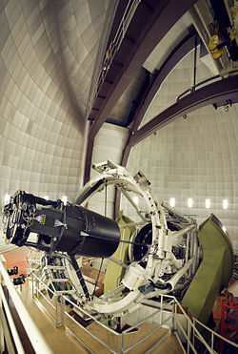
The Rotary Club of Coonabarabran will be holding a camp in May for young people who are interested in astronomy. The camp is known as RYSTARS (Rotary Youth Studying Astronomy and Related Sciences).
The camp will be held from 4pm on Thursday 4 May to 1.30pm on Sunday 7 May.
The camp will provide activities, seminars and workshops run by professional and amateur astronomers resident in Coonabarabran.

These will include activities such as:
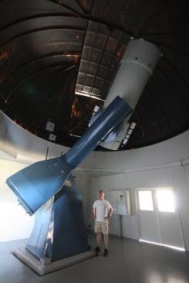
- Learning about, and how to assemble different telescopes
- Visiting a variety of telescopes in the area, including a guided tour of the 3.9m AAO telescope at Siding Spring and a visit to the 40 inch telescope at ‘Milroy’
AAO
- Night time observing (weather permitting)
- Experiences with remotely operated telescopes which are situated in different parts of the world
Accommodation will be at the Warrumbungles Mountain Motel, with supervision by Coonabarabran Rotarians.
‘Milroy’
Cost - $300.00. This covers all meals, travel to venues and entrance fees.
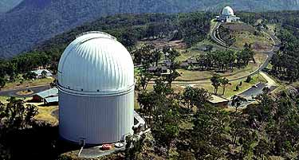
Numbers will be restricted to 20 students, and will be allocated on a ‘first come, first served’ basis. In order to spread involvement across the district and beyond as fairly as possible, it may be necessary to limit applications to two per school.
Arrangements for travel to and from Coonabarabran are the responsibility of the student.
Participants may wish to approach their local Rotary Club about this venture and their interest in attending - some clubs may consider subsidising attendance costs. A more detailed program of activities will be sent to those who nominate to attend.
NOMINATIONS, using the enclosed Nomination form WILL CLOSE FRIDAY 21 April 2017
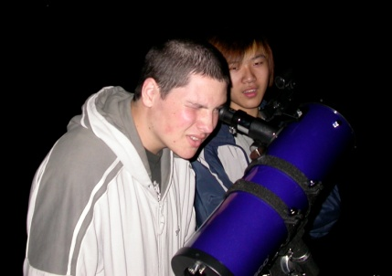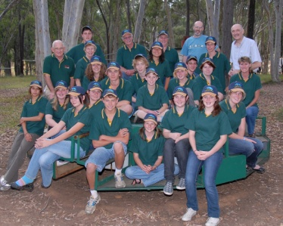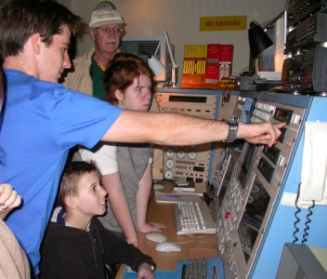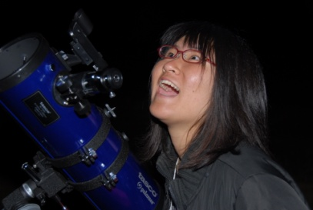
‘It was awesome!’ ‘Loved it … best camp I’ve been on.’ ‘A fantastic experience which really opened my eyes to the wonders of astronomy.’ ‘Excellent & very worthwhile, I’m very happy that I came.’ - Student evaluations.

